|  |  |
| --- | --- |
| A picture of a winding road and trees  Reamogetse chane  ST10444936 | WEDE5020  POE PART 1 |

Contents

1. Website choice 2

Purpose 3

2. Website Asset 3

3. Website Pages and Content. 9

Homepage 9

Services 9

News 9

About us 10

Contact us 10

References 11

# Website choice

## Purpose

The **ASG logistics** it is an organisation that will focus on delivery coordination. It is a similar courier company but this organisation it will mostly use Air courier deliveries instead of trucks or vans that carry goods and services to customers. ASG LOGISTICS is not only to make a profit for a business but also to satisfy the needs of the customer on higher level. Customers always want their products to be delivered fast but being much faster makes the business unique from others. Customers always stress about the safety but the chances of Aircraft being robbed is very slim. Chances of the business being involved in accidents are slim because ASG Logistics uses airplanes/ aircrafts which moves much faster and safer than shipping which sometimes their ships get attacked or hijacked by the pirates. However, with Air courier delivery will not take than a week. The delivery of ASG is the same as going to the store and buying because it takes the same amount of time, so with the use of drones will become effective as a mode of transport delivery to customers. This business company does not only provide service delivery to only one country but also globally. Our mode of transport will be equipped with high technology, this includes the drones will have high tech-cameras for the operators to locate and deliver the goods.

The business will grow and get wide range of customers using this service delivery and this means more profit. And the main mission of the business is for customers to get their goods and services safely and quick.

# Website Asset

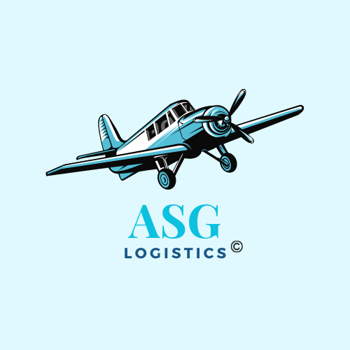

Figure 1: Logo

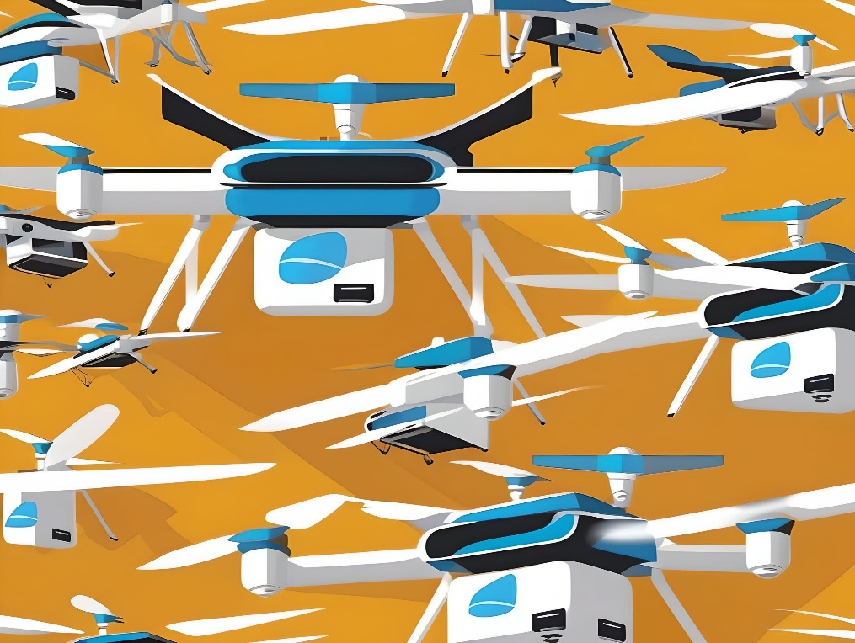

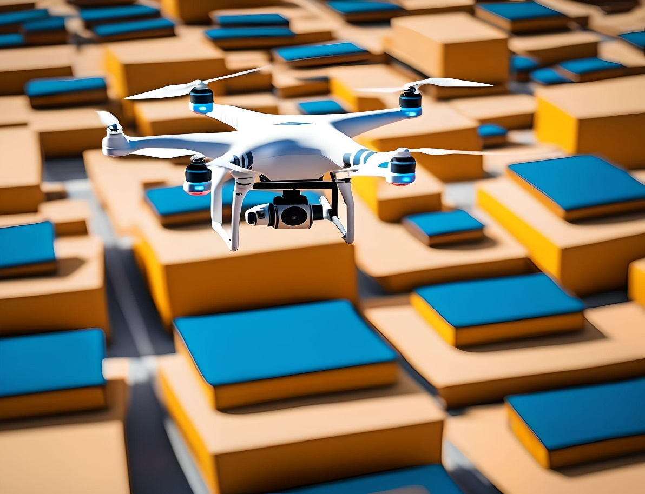



Figure 2: Goods & Services being shipped.

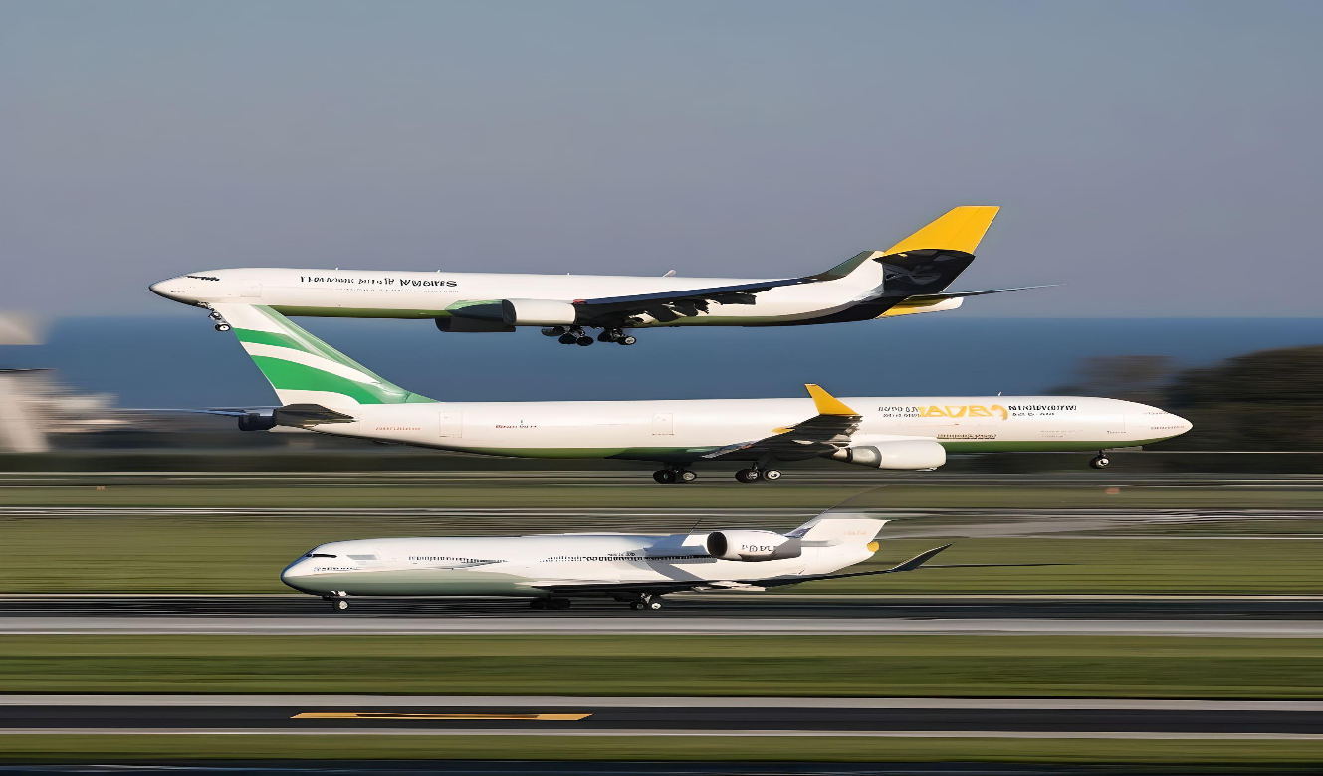

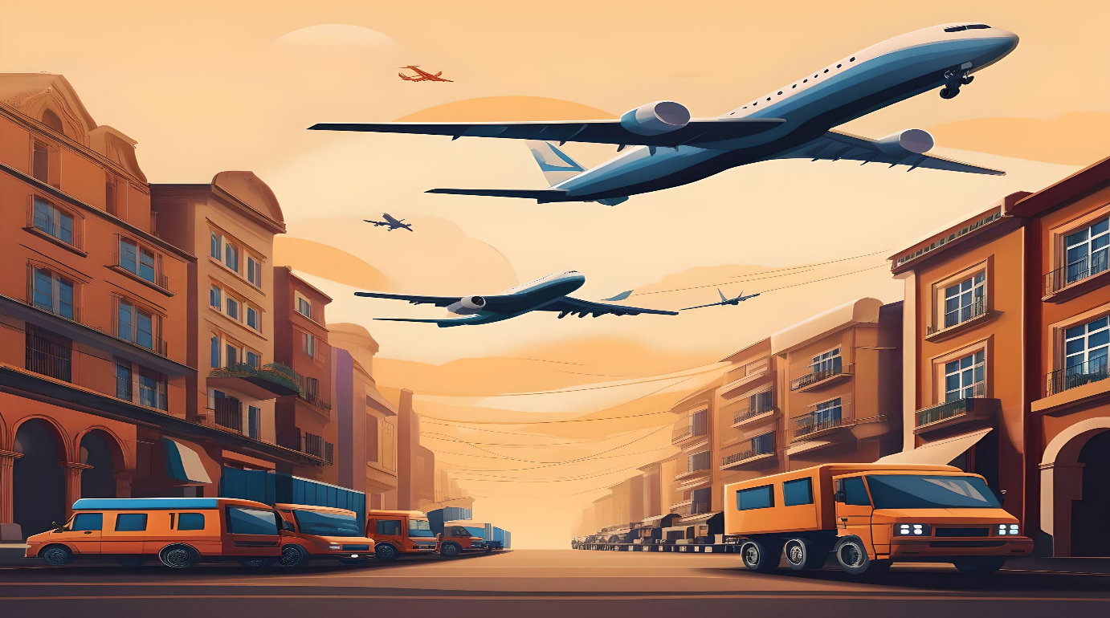

Figure 3: Goods & Services being transported.

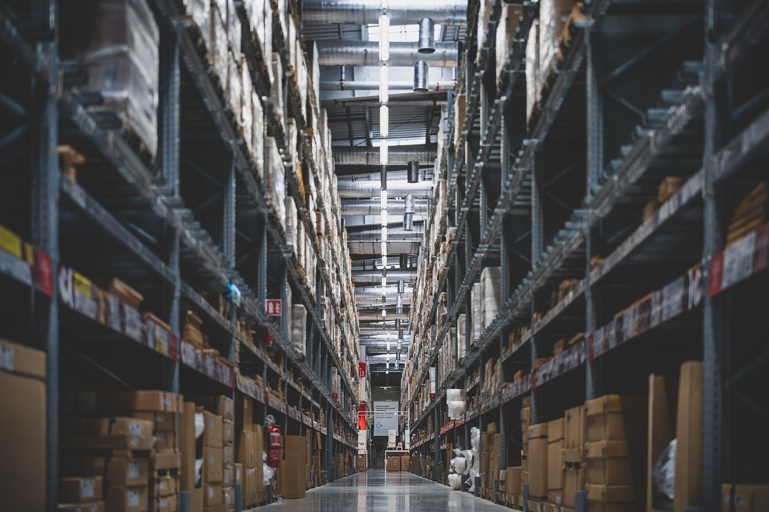

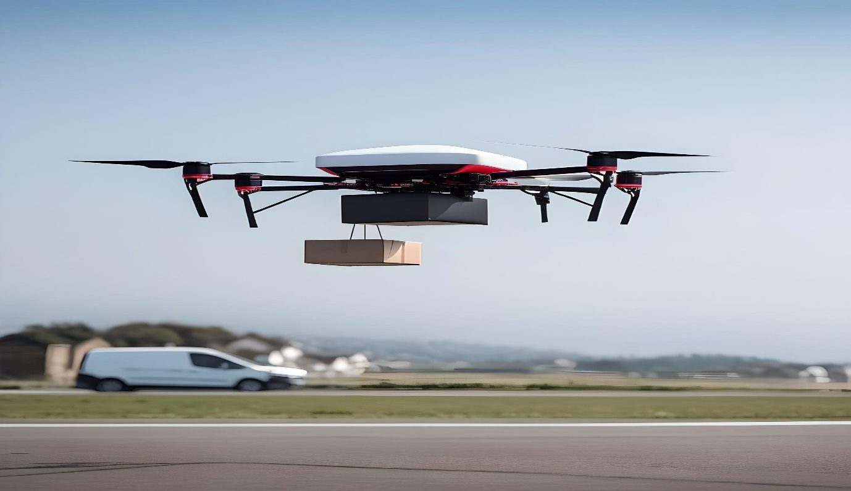

Figure 4: Drones ready to act.

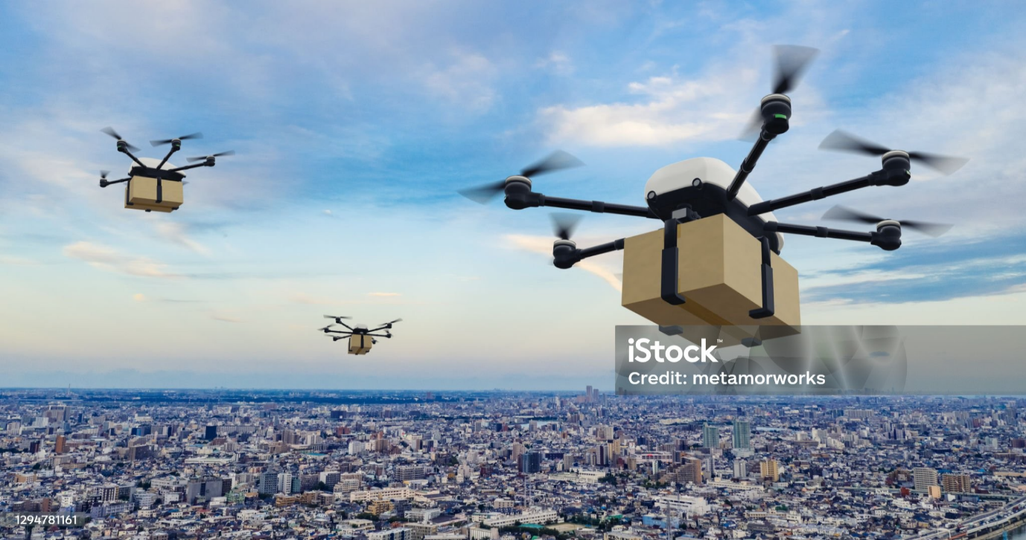

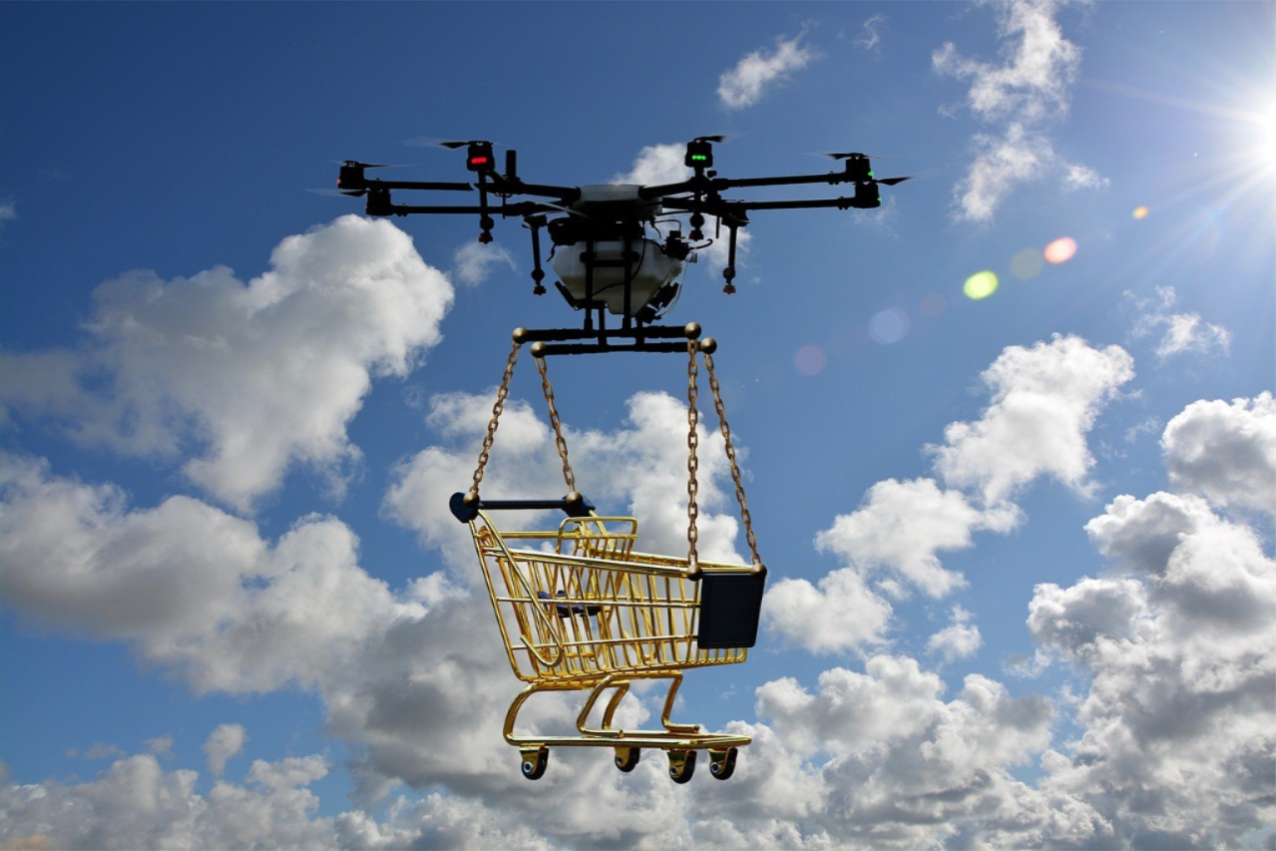

Figure 5: Drones can carry more load.

# Website Pages and Content.

## Homepage

Faster than a blink of an eye

## Services

This webpage consists of our services being illustrated.

Our drones can reach various area locations with the help of equipped high-tech camera to reach their destinations and satisfy customers. Order your products and use ASG company as mode of delivery services and get an experience with the use of our service and receive your parcel within a day.

## News

Delivery Fee charges dropping

In recent months, delivery fee charges have seen a notable decline, benefiting consumers who frequently order goods and services online. This reduction can be attributed to increased competition among delivery platforms, advancements in coordination technology, and growing customer demand for more affordable options.

As companies strive to attract and retain customers, we are finding innovative ways to lower operational costs, passing on the savings to consumers in the form of reduced fees. This trend is expected to continue, making online shopping and delivery services more accessible and cost-effective for a broader audience.

Our Drones will be carrying load weight goods & services

Our drones are set to revolutionize the delivery industry by carrying load weight goods and services efficiently and reliably. These advanced drones are designed to handle substantial payloads, ensuring that even heavier items can be delivered swiftly and securely. By leveraging innovative technology, our drones can navigate complex environments and reach destinations faster than traditional delivery methods. This innovation not only reduces delivery times but also minimizes costs, providing customers with a more convenient and affordable service. As we continue to expand our drone fleet, we are committed to enhancing the delivery experience for all.

## About us

This webpage consists of the purpose of the business and the founders of the business.

## Contact us

This page has contact details about the website and if customers want to reach the staff and want to enquire about the services.

# References

iStock. 2021. Drone delivery concept. Autonomous unmanned aerial vehicle for transporting packages. [Online]. Available at: <https://www.istockphoto.com/de/foto/drohnen-lieferkonzept-autonomes-unbemanntes-luftfahrzeug-zum-transport-von-paketen-3d-gm1294781161-388678661> [Accessed on: 7 August 2024].

Marcofedermann. 2021. Port Container Cranes Sunset. [Online]. Available at: <https://pixabay.com/photos/port-container-cranes-sunset-river-6131793/>[Accessed on 7 August 2024].